How to download YouTube videos

- Get URL for YouTube video
- Open VLC player and click Media-Open Network Stream (Ctrl+N)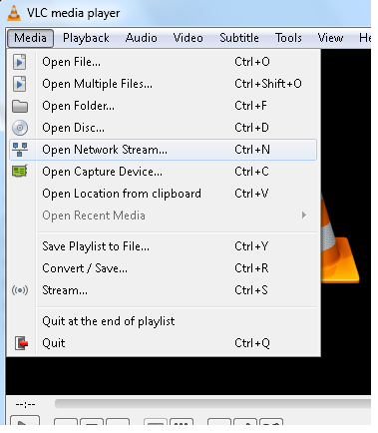
- Paste in the URL and click Play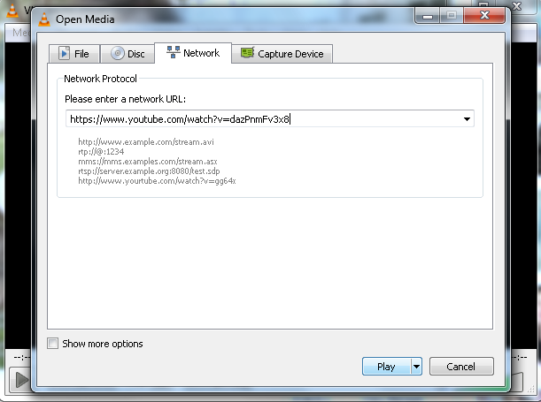
- When video plays – Right click-Tools-Codec Information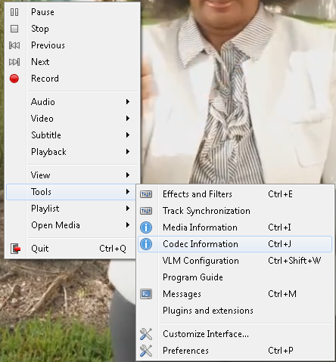
- Copy the URL in the Location box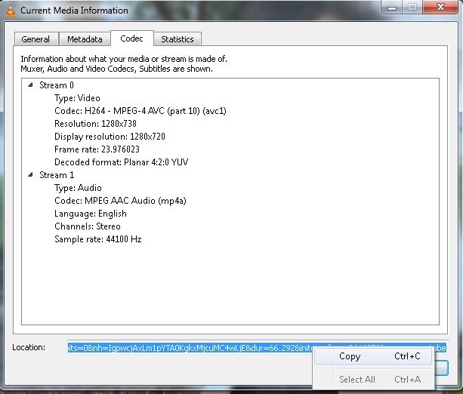
- Paste the URL into a browser and play
- Right click- Save video as 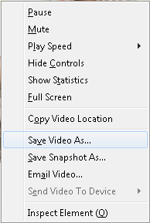
- Save video to desired location.

