Fast Facts: Assistive Listening Systems: An Introduction

Overview

Background noise and distance from the instructor may present barriers for some students who are deaf or hard of hearing. When this is the case, assistive listening systems can play a role in reducing or eliminating these barriers.

What are assistive listening systems?

The term assistive listening systems (ALS) describes a variety of technologies that reduce the barriers that result from distance and surrounding noise. Assistive listening technologies range from pre-installed systems that are built into an auditorium or classroom to small, portable devices that can be carried from class to class. These smaller systems are often referred to as assistive listening devices, or ALDs. Sometimes described as “binoculars for the ears,”¹ assistive listening technologies allow the listener to tune directly into a speaker’s voice.

While hearing aids can be very effective and have improved dramatically in recent years, they still do not compare to the ear’s natural ability to filter out extraneous noise. A person coughing, the hum of an air conditioner, people talking in the hall—all of these sounds can eclipse the voice of the speaker and result in the individual missing critical information. Imagine if you were in a noisy restaurant with a friend and you could turn up the volume of your friend’s voice without increasing the volume of all the people around you. In effect, this is what is accomplished through the use of an assistive listening system.

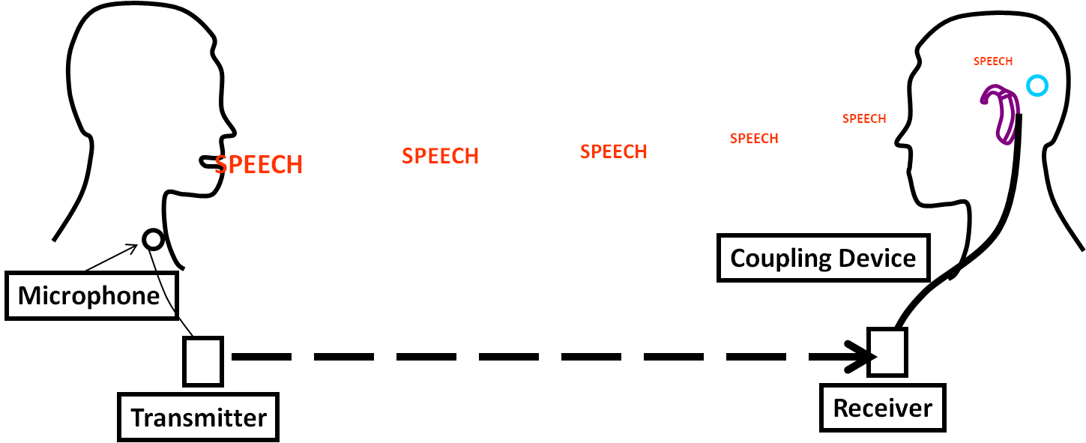

A simple explanation of the process involved can be described as “catch, carry, couple.”¹ A microphone catches the speaker’s voice. A transmitter converts it to an electronic signal and carries the signal to a receiver which is coupled to the student.

What are the different types of assistive listening systems and how do they work?

There are a variety of types and configurations of assistive listening systems. Two types of portable systems are frequency modulated (FM) systems and infrared systems. The systems that are less portable, or sometimes even permanently installed, are induction loops.

Portable systems or assistive listening devices (ALDs) include four pieces: a microphone (usually a lapel mic), a transmitter, a receiver, and a coupling device. FM systems transmit a radio signal and can be set to various channels. The signal of a typical system can travel up to 100 feet and through walls. Infrared systems, as the name implies, send the signal by way of an infrared light, so the transmitter and receiver require a clear line of sight between them. With both of these systems, the instructor wears a lapel mic connected to a transmitter. The student wears a receiver with a coupling device (headphones or a neckloop).

An induction loop can be built into the infrastructure of a room or may be a wire loop that surrounds a specific seating area within a room. The speaker speaks into a microphone which is connected to an amplifier that powers the loop. The loops sends an electromagnetic signal that can be picked up by anyone with a hearing aid or cochlear implant that includes a telecoil.

What do instructors need to consider when using an ALD?

The following considerations will increase an instructor’s effectiveness in using assistive listening devices. A conversation with the student regarding what works best is also recommended.

- Check the transmitter before beginning the lecture. Perform a quick sound check with the student to make sure the transmitter and receiver are working properly.
- Make sure to turn the unit off when not in use. Instructors should keep in mind to turn the transmitter off when they are having private conversations. They should also turn it off and when clipping the mic onto (or removing it from) their clothing.
- Students using the ALD will not be able to hear comments from classmates unless their classmates are speaking into the mic. Instructors should repeat brief comments or questions from other students or pass the mic to students who are making longer comments.
- If the student is using an infrared system, make sure seating near the front of the room is available. The instructor will also need to stand so that objects such as a podium or AV equipment are not blocking the signal.
- When showing videos, the student may want to place the receiver near the audio speaker. When the instructor plans to show a video, it is ideal to discuss this with the student before class so the best arrangements can be made to provide access.

When disability service providers understand the basics of how assistive technology works, they can play a role in assisting students and the campus community as a whole in removing the barriers experienced by many people who are deaf or hard of hearing. For a more in-depth look at making choices about assistive listening systems on your campus, see pn2’s Fast Fact titled Assistive Listening Systems: Choosing the Right Technology for Your Campus.

Highlight Box (on page 1):
What is a telecoil?
A telecoil or t-coil is a small wire coil inside a hearing aid or cochlear implant that picks up the magnetic signal transmitted by assistive listening systems. It is activated by what is referred to as a t-switch. When the t-switch is on, the microphone that picks up environmental sounds is deactivated, thus the person only hears those sounds being transmitted by the ALS.

Highlight Box (on page 2):
Assistive listening devices may also remove barriers to attending for hearing students with attention deficit disorder and students with auditory processing disorders. Several studies have demonstrated these benefits. The request for an ALD by students with other disabilities may also be considered a reasonable accommodation.

Resources

Pepnet2: Demystifying Hearing Assistance Technology: A guide for Service Providers and Consumers http://www.pepnet.org/sites/default/files/Demystifying.pdf

Hearing Loss Association of America- Hearing Assistive Technology http://www.hearingloss.org/content/hearing-assistive-technology
References

¹ Comptom-Conley, C. (2015). Comparison of large area assistive listening systems [PDF Document]. Retrieved from Hearing Loss Association of America http://www.hearingloss.org/sites/default/files/docs/Comparison_of_LargeAreaALS.pdf

² U.S Department of Justice, Effective Communication. Retrieved from
http://www.ada.gov/effective-comm.htm

Note: Graphic used with permission of Samuel R. Atcherson, Ph.D.

