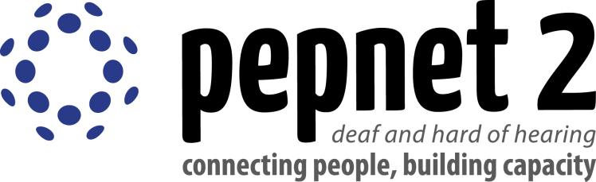
Improving Systemic Access for Positive
Post-School Outcomes with Deaf and
Hard of Hearing Individuals

Cindy Camp Shannon Aylesworth
cindy.camp@pepnet.org Shannon.aylesworth@pepnet.org
AHEAD Conference July 2015

What is pepnet 2?
Pepnet 2 (pn2) is a federally funded project whose mission is to increase the education, career, and lifetime choices available to individuals who are deaf or hard of hearing. We do this by supporting the professionals who work with these individuals.
We provide:
- Live trainings
- Online modules available 24/7
- Online facilitated trainings
- Technical Assistance and Live Chat
- Training materials online and for download
- Evidence based resource to support your work

Presentation Goals
- Explore the systemic barriers that exist in higher education
- Briefly clarify the relationship between full access to equal opportunities and successful outcomes
- Discuss strategies for implementation at your institutions to encourage full access and equal opportunities for students who are deaf or hard of hearing

What is Systemic Discrimination?
Systemic discrimination refers to patterns of behavior, policies or practices that are part of the structures of an organization, and which create or perpetuate disadvantage for racialized persons. It has a broad impact on an industry, profession, company, or geographic area. http://definitions.uslegal.com/s/systemic-discrimination/
What are types of systemic barriers?
- Attitude
- Communication
- Physical
- Programmatic
http://www.uottawa.ca/respect/sites/www.uottawa.ca.respect/files/accessibility-cou-understanding-barriers-2013-06.pdf
http://www.ncwd-youth.info/attitudinal-barriers-for-people-with-disabilities
Why is this important?
Attitudes Matter
- Positive energy is contagious
- Knowing someone genuinely cares is motivating
- Being valued makes us feel energized

Have you ever felt discrimination?
Discrimination is defined as: …the unjust or prejudicial treatment of different categories of people…
Even small gestures can be seen as discrimination. These can lead to a negative attitude on campus.

Have you ever felt included?
Inclusion is defined as: “.. a sense of belonging: feeling respected, valued for who you are; feeling a level of supportive energy and commitment from others so that you can do your best.”
Miller, Frederick A. and Katz, Judith H. 2002. The Inclusion Breakthrough: Unleashing the Real Power of Diversity. San Francisco: Berrett-Koehler Publishers
Again small gestures can make a world of difference. Just smiling at someone can brighten their day. Being willing to communicate with individuals who are deaf or hard of hearing and while not freaking out is a great starting point.

Social Model vs. Medical Model of Disability
The social model of disability identifies systemic barriers, negative attitudes and exclusion by society (purposely or inadvertently), which means that society is a contributory factor in disabling people.

Social Model  - Person is identified with a condition (i.e. person with hearing loss)  - View deafness as a cultural minority.  - Sign language is the natural language of deaf people  - Deafness is something to be proud of. | Medical Model  - Person is defined by their condition (i.e. Deaf person)  - View deafness as something that needs to be “fixed.”  - Speech and lip reading are preferred.  - Hearing loss is shameful and should be hidden.
Resources:
http://www.artbeyondsight.org/dic/definition-of-disability-paradigm-change-and-ongoing-conversation/
http://www.ncwd-youth.info/attitudinal-barriers-for-people-with-disabilities
http://www.managementstudyguide.com/overcoming-communication-barriers.htm

As you look at changing the approach to students with disability on your campus it is important to look at how different areas view students with disabilities.
In the Disability Support Services office:
- How are students who are deaf or hard of hearing greeted when they enter your office?
- What is your process for requesting services?
- What is your complaint process?
In the classroom:
- What is the typical reaction of instructors when informed that a student who is deaf or hard of hearing is in their classroom?
- How are service providers viewed?
On campus in general:
- How do individuals who are deaf or hard of hearing request access to special events?
- Are captions displayed on TVs in public areas?

Visit YouTube to see the story of one deaf individual and his experience with discrimination.
https://www.youtube.com/watch?v=PbRv5X7Jyno

Think about how you can make students feel included on your campus. This YouTube video shows a campus that is deaf friendly. https://www.youtube.com/watch?v=5lb_53ct1NA

Creating an inclusive campus has benefits for everyone.
- When students feel accepted and welcome retention rates go up.
- Creating access for students who are deaf or hard of hearing also increases access for all students. For example turning captions on in the Student Union building means everyone has access. They help provide information when there is a noisy background and benefit ESL students on campus.
- Increased diversity on campus benefits all students.
- It promotes a shared sense of community.

Consider what steps you can take to welcome students who are deaf and hard of hearing to your campus.

How Can You Access pn2?
- http//www.pepnet.org
- help@pepnet.org
- Live Chat Online
- “Like” us on FaceBook: pepnet2
- Follow Us on Twitter: pepnet2

Pepnet 2 receives support from:
pepnet 2 is funded by the Research to Practice Division,
Office of Special Education Programs
and the US Department of Education
via Cooperative Agreement #H326D110003

